interface

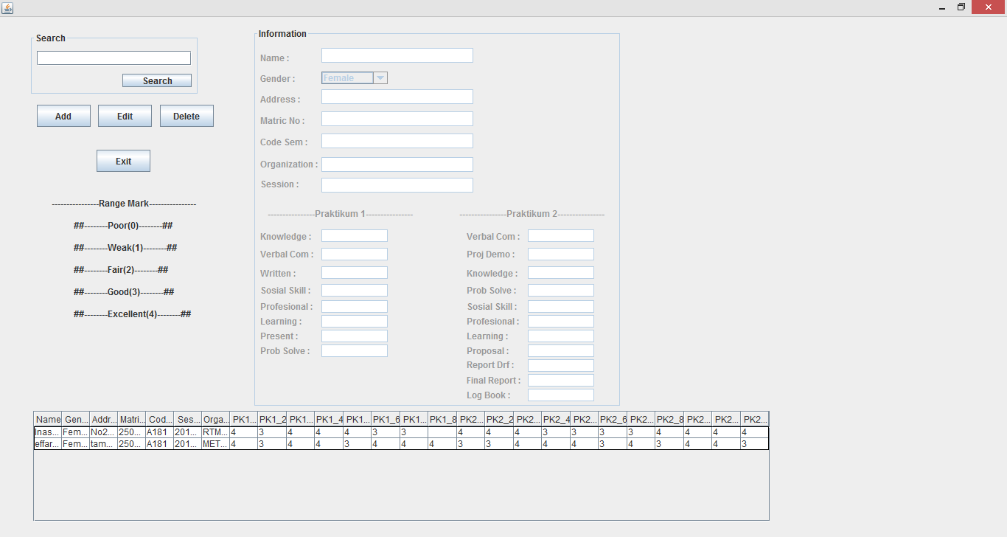

search

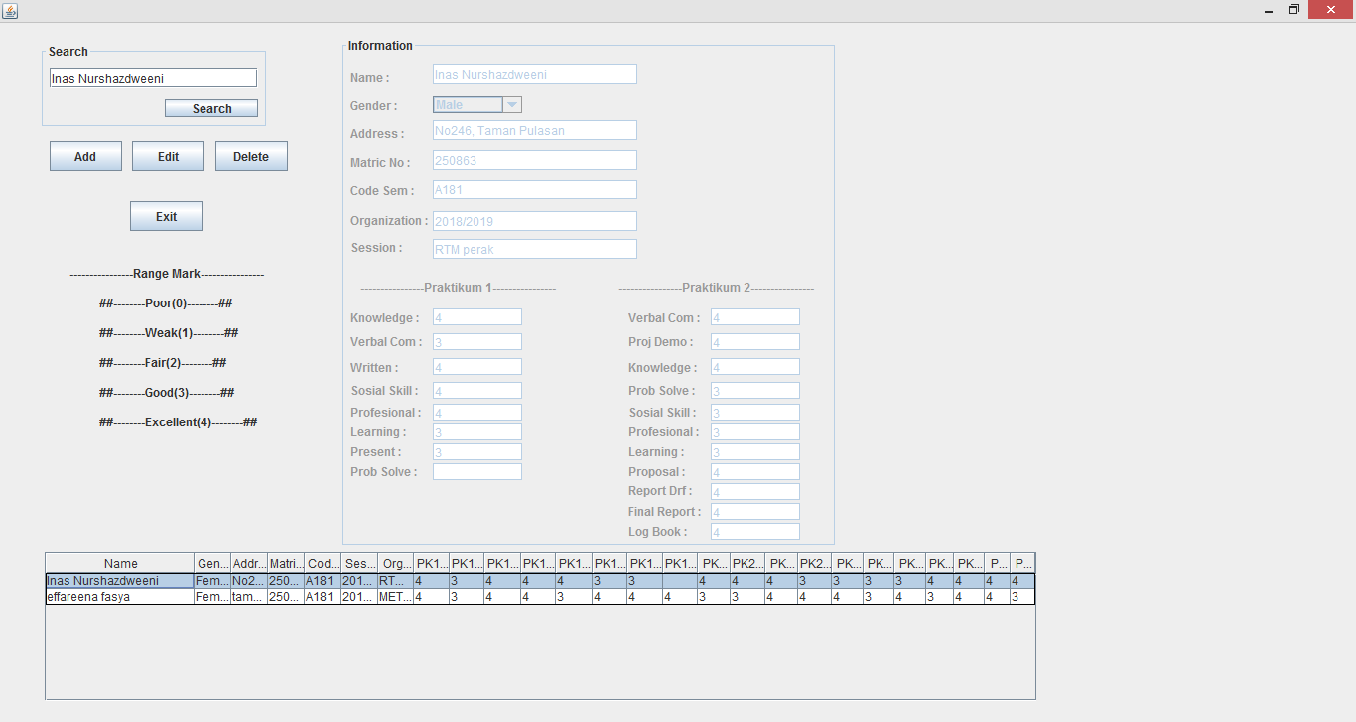

update

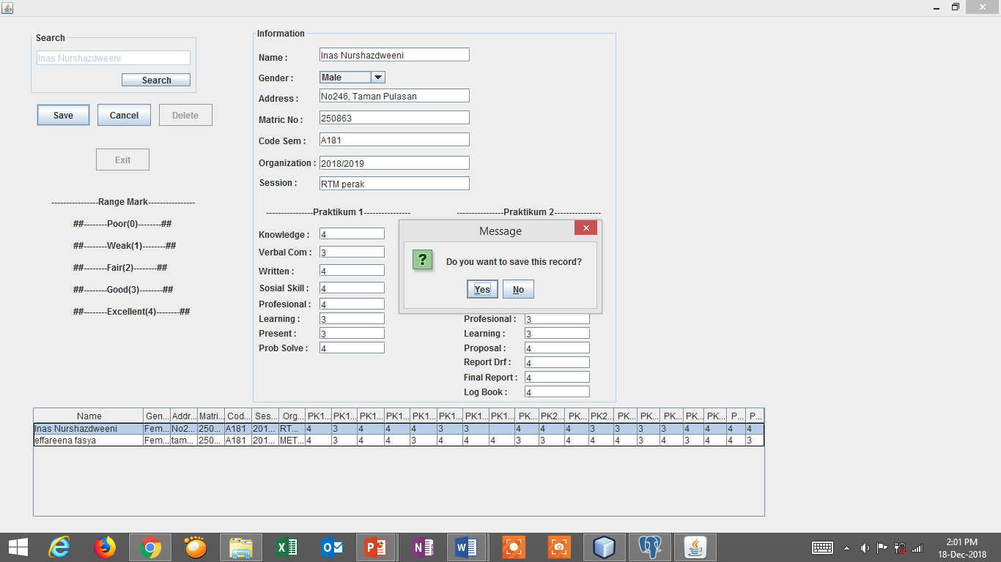

add

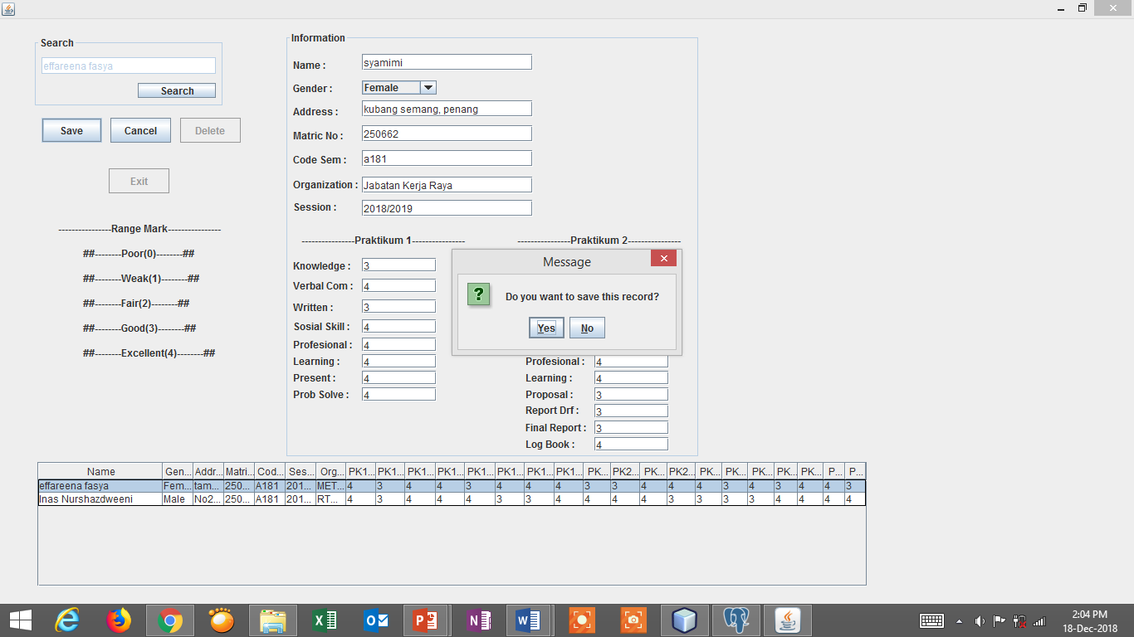

delete

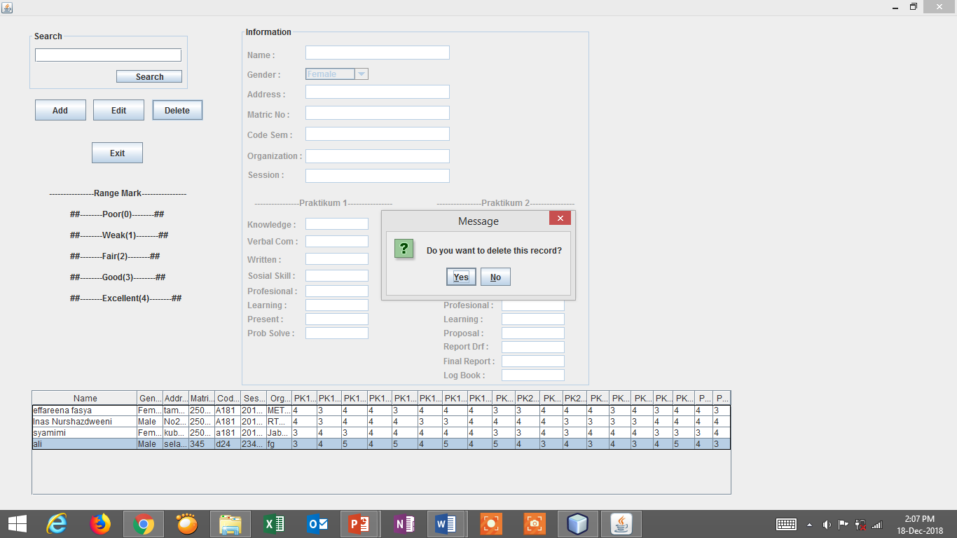

Data dlm postgresql

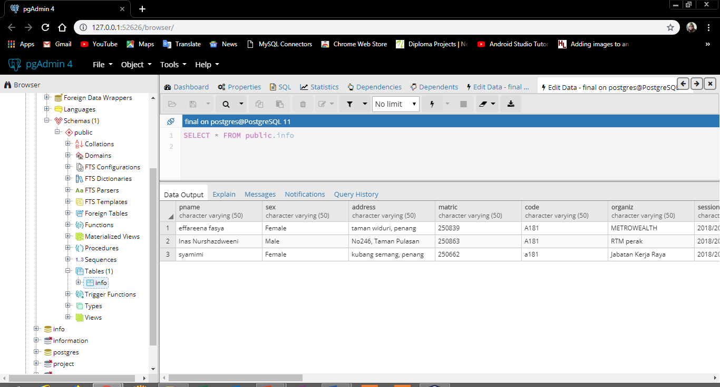

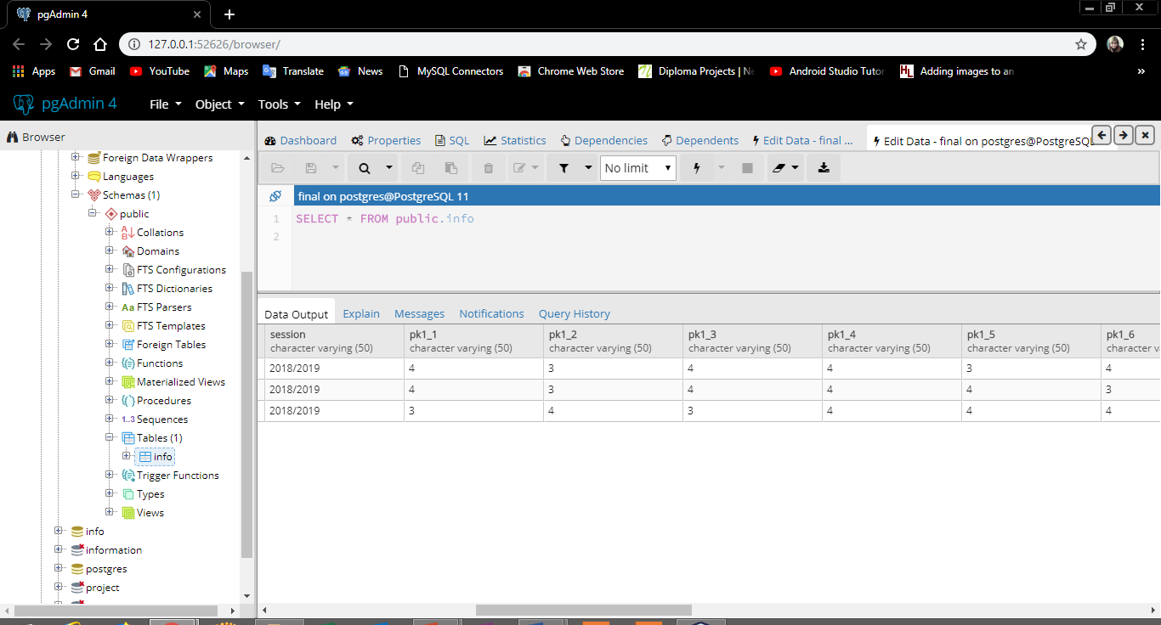

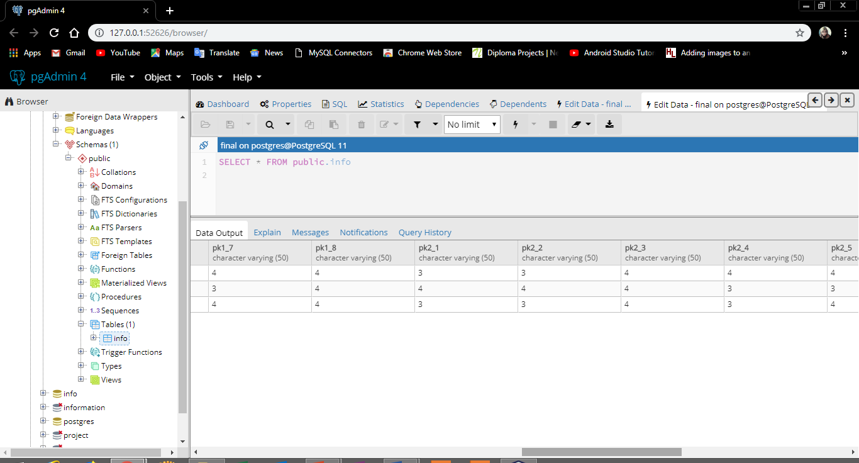

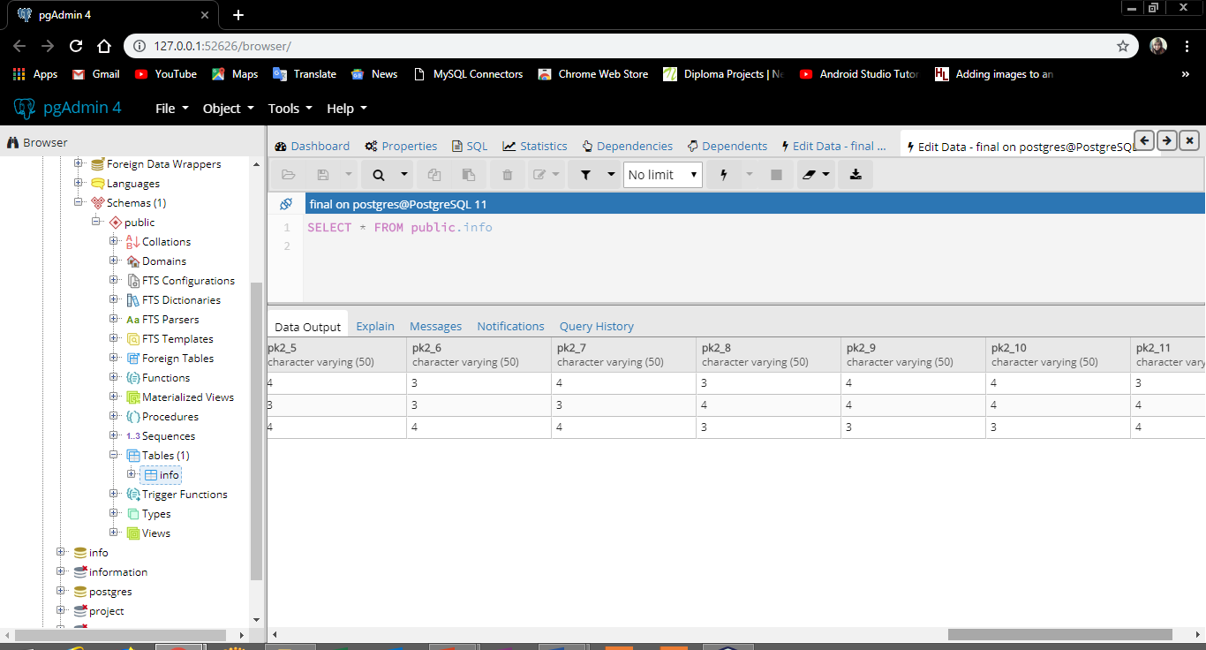

postgresql

database name : final

CREATE TABLE IF NOT EXISTS info (

Pname varchar(50) NOT NULL,

sex varchar(50) NOT NULL,

address varchar(50) NOT NULL,

Matric varchar(50) NOT NULL,

Code varchar(50) NOT NULL,

Session varchar(50) NOT NULL,

Organiz varchar(50) NOT NULL,

Pk1_1 varchar(50) NOT NULL,

Pk1_2 varchar(50) NOT NULL,

Pk1_3 varchar(50) NOT NULL,

Pk1_4 varchar(50) NOT NULL,

Pk1_5 varchar(50) NOT NULL,

Pk1_6 varchar(50) NOT NULL,

Pk1_7 varchar(50) NOT NULL,

Pk1_8 varchar(50) NOT NULL,

Pk2_1 varchar(50) NOT NULL,

Pk2_2 varchar(50) NOT NULL,

Pk2_3 varchar(50) NOT NULL,

Pk2_4 varchar(50) NOT NULL,

Pk2_5 varchar(50) NOT NULL,

Pk2_6 varchar(50) NOT NULL,

Pk2_7 varchar(50) NOT NULL,

Pk2_8 varchar(50) NOT NULL,

Pk2_9 varchar(50) NOT NULL,

Pk2_10 varchar(50) NOT NULL,

Pk2_11 varchar(50) NOT NULL

)